|  |  |
| --- | --- |
| Assignment CoverSheet |  |

|  |  |
| --- | --- |
| Student Name: Engouindi Kendrick | |
| Class: Digital Image Creation and Development | |
| Assignment: Identification and evaluation of digital imagery | |
| Lecturer: David Petryca | Semester: 1804 |
| Due Date: November 18, 2018 | Actual Submission Date: |

|  |  |  |
| --- | --- | --- |
| **Evidence Produced (List separate items)** | **Location (Choose one)** | |
| Technical report (PDF) | x | Uploaded to the Learning Center (Moodle) |
|  | Submitted to reception |
| *Note: Email submissions to the lecturer are not valid.* | | |

|  |  |
| --- | --- |
| **Student Declaration** | |
| **I declare that the work contained in this assignment was researched and prepared by me, except where acknowledgement of sources is made.**  **I understand that the college can and will test any work submitted by me for plagiarism.**  **Note:** The attachment of this statement on any electronically submitted assignments will be deemed to have the same authority as a signed statement | |
| Date: | Student Signature: |

A separate feedback sheet will be returned to you after your work has been graded.   
Refer to your Student Manual for the Appeals Procedure if you have concerns about the grading decision.

|  |
| --- |
| **Student Comment (Optional)** |
| Was the task clear? If not, how could it be improved? |
| Was there sufficient time to complete the task? If not, how much time should be allowed? |
| Did you need additional assistance with the assignment? |
| Was the lecturer able to help you? |
| Were there sufficient resources available? |
| How could the assignment be improved? |
| *For further comments, please use the reverse of this page.* |

Identification and evaluation of digital imagery

Kendrick Engouindi



Course: Digital Image Creation and Development

Lecturer: David Petryca

Assignment: 1. Identification and evaluation of digital imagery

Due date: November 18, 2018

Submission date:

Semester: 1701

Word count: 1157

Table of contents

# Introduction

In this report we’ll present you and talk about an advertisement made by Apple Inc. which is an American multinational technology company headquartered in California. Apple’s advertisements are made by TBWA\Media Arts Lab which is also a Californian company. TBWA was created in 1984 and works with a lot of multinationals such as Adidas, MacDonald’s, Michelin, etc.

Apple advertises their products by making a big gleaming title usually comparing their products to other ‘basic’ products such as “Life is easier on iPhone.”, “Like a computer. Unlike any computer.”, “Thinner than all.”.

Apple is great at advertising their products. But today we will specifically focus on their new MacBook’s advertisement (Figure 1.). I chose this specific advertisement because it caused a lot of talk on some forums and is composed of a logo, picture, text formats and is well structured. We will go step by step and come up with a result letting us know if the advertisement’s title is complying with the product.

# Body

## The big title.

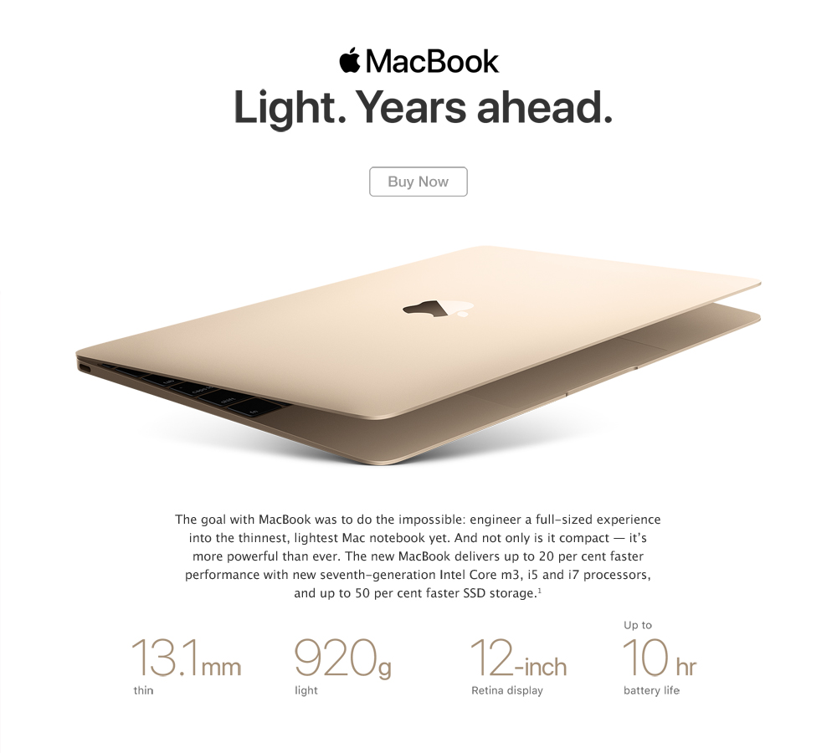

Figure 1.

The Figure 1. above is the advertisement made by/for Apple Inc. We can see that the title is the biggest text on the whole page but also is black and bold. As soon as you put your eyes on the picture, it’s the very first thing you can see. The title is used in 2 ways. Thirst, there’s the word “Light” which represents the weight of the computer. With a weight under 1 kg, Apple can totally shout loud and clear that they have one of the lightest computers every made. The second part is “Years ahead” which represents the technological advancement of MacBook’s computers.  
The second way to read the text and which a lot of people think is the way it was mean to be read is “Light Years ahead”. A light year is a unit used in astronomy to represent very (very) long distances (almost) impossible for human beings to reach.

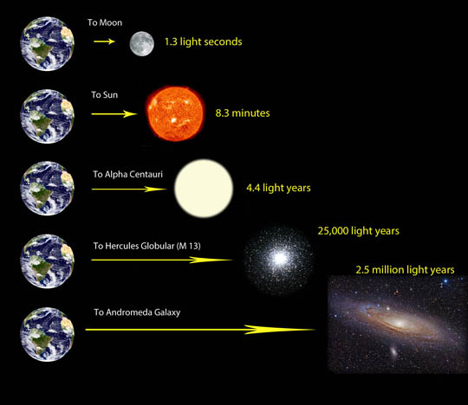

Figure 2.

The figure 2. above is a representation of how long the light will take to reach different celestial objects. A light year is the distance the light will travel over a year. Alpha Centauri is 4.4 light years away from us. Which means that a light ray leaving earth will spend 4.4 years before reaching Alpha centaury. In Kilometers this distance represents 41627214079356 Kilometers or 4.1627214 x 1013 Kilometers which is an absurd number almost impossible to read. For reference, the speed of light is 300.000 km/s. The fastest speed ever reach by a flying object (manmade) is roughly 24 km/s. NASA claims that one their probe launched towards the sun will reach a speed nearly 193 km/s when passing by the star. If we can put a man in a spacecraft at that speed, he will take around 68669 centuries to reach the Galaxy.

Is Apple correctly using this Big Gleamy title? We will find it out in the next part.

## The hardware

The very first model of this MacBook was released in mid-2015 but we will talk about the latest one which has been released early June 2017.

The hardware used by Apple is usually called obsolete. But when we look at their website, there’s an indexation taking use to the end of the page and explaining that they used preproduced processors for this computer. Related to the release date of the processor used (announced on September 15, 2017) and the release date of the computer (June 5, 2017), Apple made sure to have to latest technology which is NOT event available. But is it the best they could have get?  
Even though Apple used a new processor not yet released to produce their notebooks, they are still using an old technology. This processor is using a dual-core (2 processor units) technology which is obsolete even for phones. The very first quad-core (4 processor units) phone has been released in 2011. The Apple MacBook and a Smartphone both uses Passive cooler (no fan is installed in the system to cooldown the processor).  
Apple also used an outdated Random-Access Memory (RAM). The version which the MacBook is using is called LPDDR3 which is a low power RAM memory. The older version of Intel’s processors (6th generation) already uses DDR4 which is the newest and fastest RAM available in the market. But Apple did a great job with the memory because it’s using PCIe 3.0 SSD (Solid State Drive (The small and faster brother of the Hard Drive)) which are one of the faster memory drives on the market. The average Hard drive reads and writes around 100MB/s. The average SSD will read/write around 350MB/s. Meanwhile Apple’s PCIe SSD will read/write around 1300MB/s. This is a big deal because it allows you to have a faster workflow and spend less time to load or save big files.

Apple did some good work on the hardware they used for their flagship computer, but better components could have been used to obtain a faster and better computer. We can conclude that the title does not represent the product itself. Even with a design almost perfect, this computer is light years from being light years ahead.

## The logo, texts and pictures:

Apple’s logo is a very simple shape which they used for over 40 years.

# Conclusion